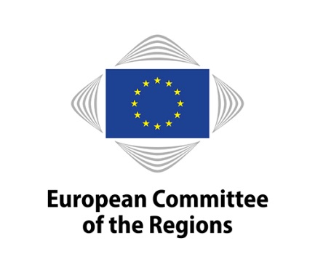
EN
MODIFICATION OF A EUROPEAN GROUPING OF TERRITORIAL COOPERATION (EGTC)

- Name of the EGTC, address and contact point (as it is currently in the EGTC register)

Official name:
Registered office:
Person responsible (Director):
E-mail address:
Internet address of the Grouping:

- Changes concerning the name, director, registered office, internet address of the EGTC
(skip if not applicable)

Modification of the official name:
Modification of the registered office's address:
Modification of the person responsible (Director):
Modification of the e-mail address:
Modification of the internet address:

- New members (skip if not applicable)

Official name:
Postal address:
Internet address:
Type of member:
Country:

- Members that left the Grouping (skip if not applicable)

Official name:
Postal address:
Internet address:
Type of member:
Country:

Person responsible:
Date and place of the signature:
Signature:

Please copy the text for each new member.
Please copy the text for each member that left the grouping

